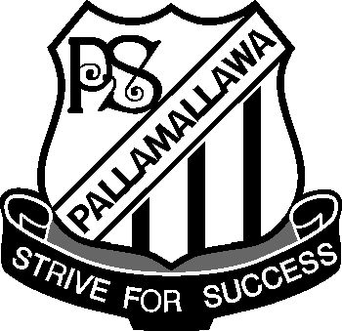 Pallamallawa

Primary School
Ph: 67 549 209
Fax: 67 549 435

Newsletter
Thursday, 9th July 2009

Trawalla Nut Pick
Last Monday we had a great day picking nuts. Thank you students, staff and parents for your assistance on the day.

Thank you Trawalla Farm for your support of our school.

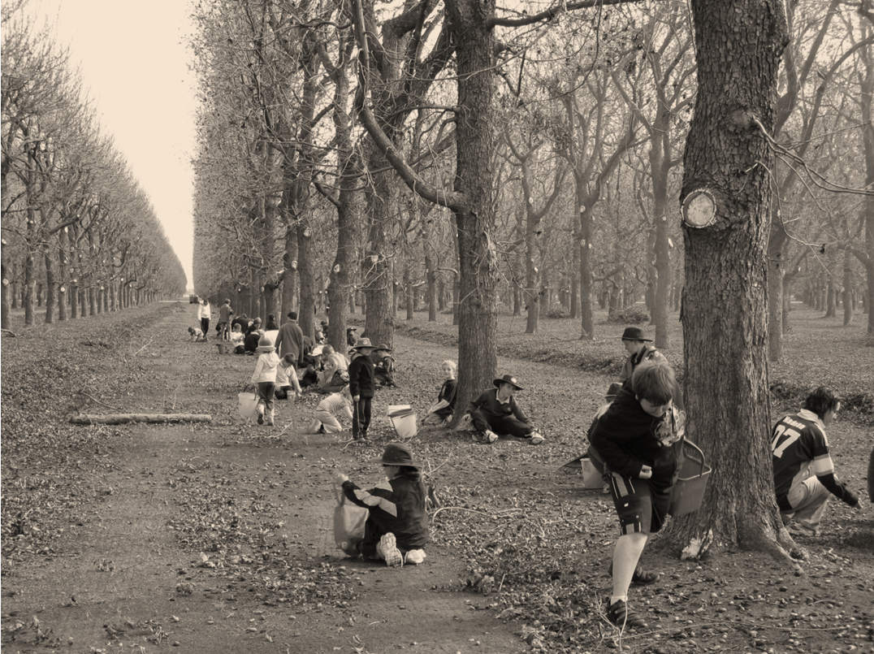

Athletics Carnival
Thank you to all the parents, carers, aunts, uncles and grandparents who joined us for the day. Thank you to all our helpers. We could not run this carnival without your support.
The house competition held at the carnival was very close with seven points between the two houses.
Wattle were the Champions with 304 points closely followed by Wilga with 297 points.
Champion Athletes Runners Up
Sub Juniors
Payton Duncan Lauren Morton
Ben Whibley Garry Goodworth-Bell
Juniors
Rhiannon Byers Sami Libbis
Wade Newcombe Harry Whibley
11yrs
Joel Dell James Whibley
12yrs
Ashleigh Newcombe Cindie Garrett
Results from the carnival have been included in this newsletter.
The Heferen Shield Moree Zone Athletic Carnival will be held on Friday, 14th August. The students competing at this carnival will be announced in Week 1 next term.

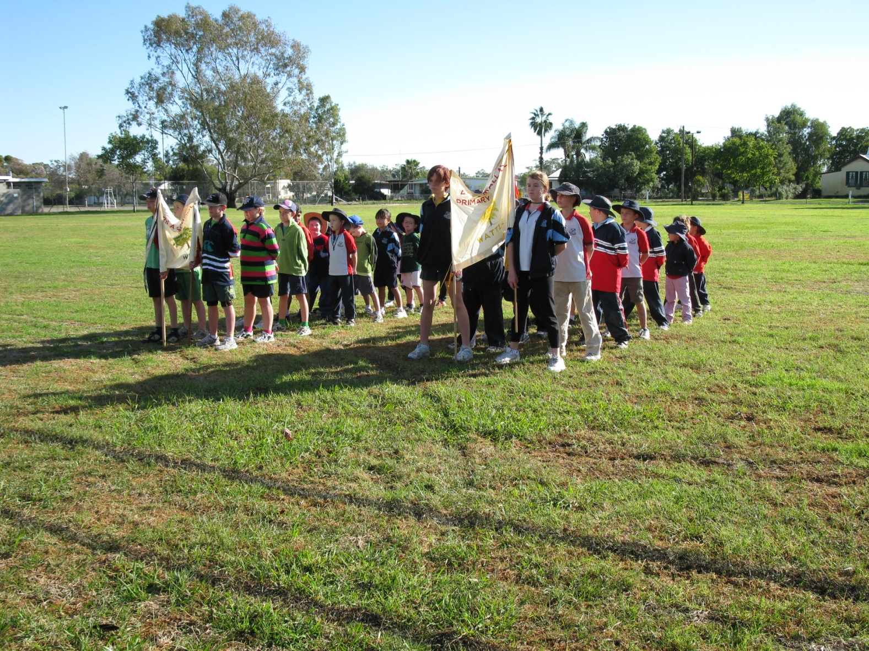

P & C Meeting Tonight 7pm

Jumpstart – 2009 Kinda Orientation/Transition to School Program
For Children who turn 5 in 2010.
On Friday 7th August we will be holding an orientation session from 9.00-10.00am for parents who will be enrolling their child at Pallamallawa Public School in 2009. At this session Mrs Annie Rush our Kindergarten Teacher will be out lining the Kinda Transition Jumpstart Program to be held for pre-schoolers at the end of Term 3 & the beginning of Term 4. The program will run for 10 weeks.

Canteen News
Thank you to all our parents who assist with canteen this term. If you can assist with canteen please contact Lynette 67549490.
There will be NO CANTEEN the first week back in Term 3.
Calendar
Term 3

July
  - Mon 27th Staff Return
  - Tue 28th Student return for start of Term 3

August
  - Sat/Sun 1st/2nd Campdraft
  - Fri 7th Jumpstart Parent Information Session
  - Fri 14th Heferen Shield Athletic Carnival

September
  - Wed 2nd Performance - Drumbeat
  - Thur 3rd PSSA Small Schools Touch Gala Day – Pally Hosting
  - Sat 12th 125years Pallamallawa School Celebration
  - Thur 24th Public Speaking Competition
  - Wed 30th Excursion Dubbo Zoo

P & C News
Campdraft 1st & 2nd August.
Reminder Working Bee on the Saturday 11th July. All help will be appreciated.
Helpers required for Canteen. Contact Maria Morton

NAIDOC Celebrations
Today the students celebrated NAIDOC Day with a Flag Raising Ceremony, jewellery making and craft activities.

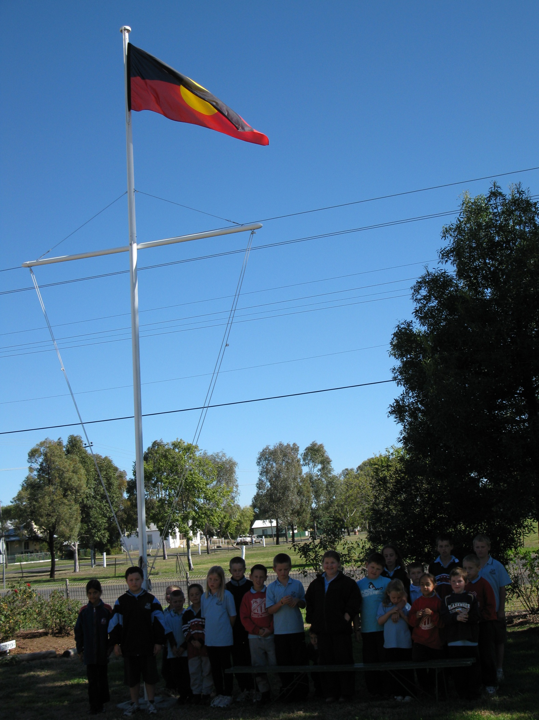

2009 Athletic Carnival
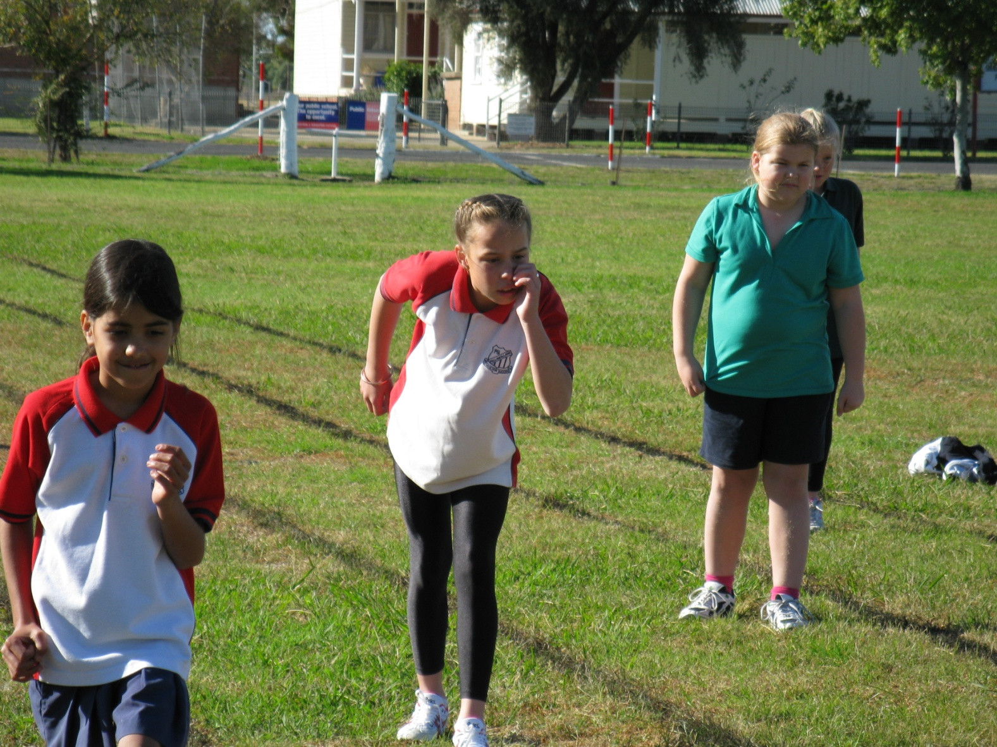

Our Champions

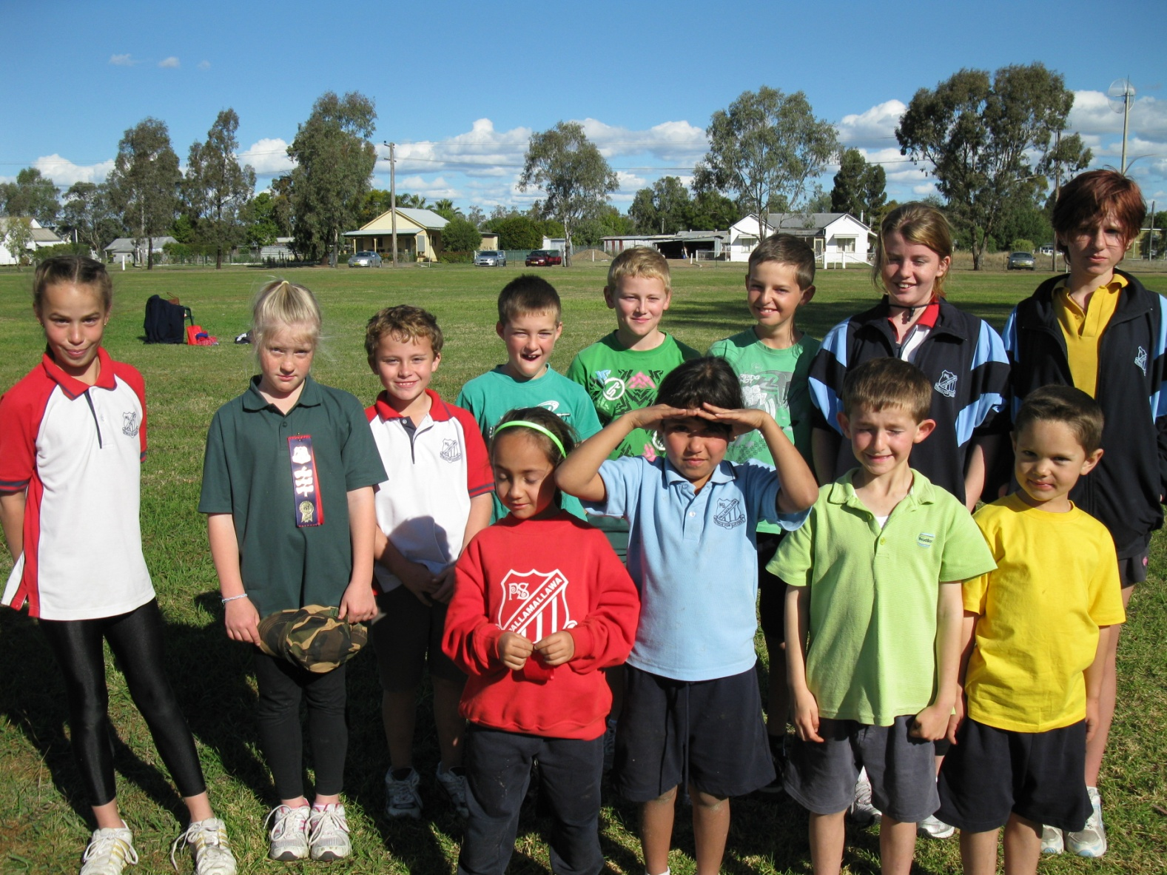

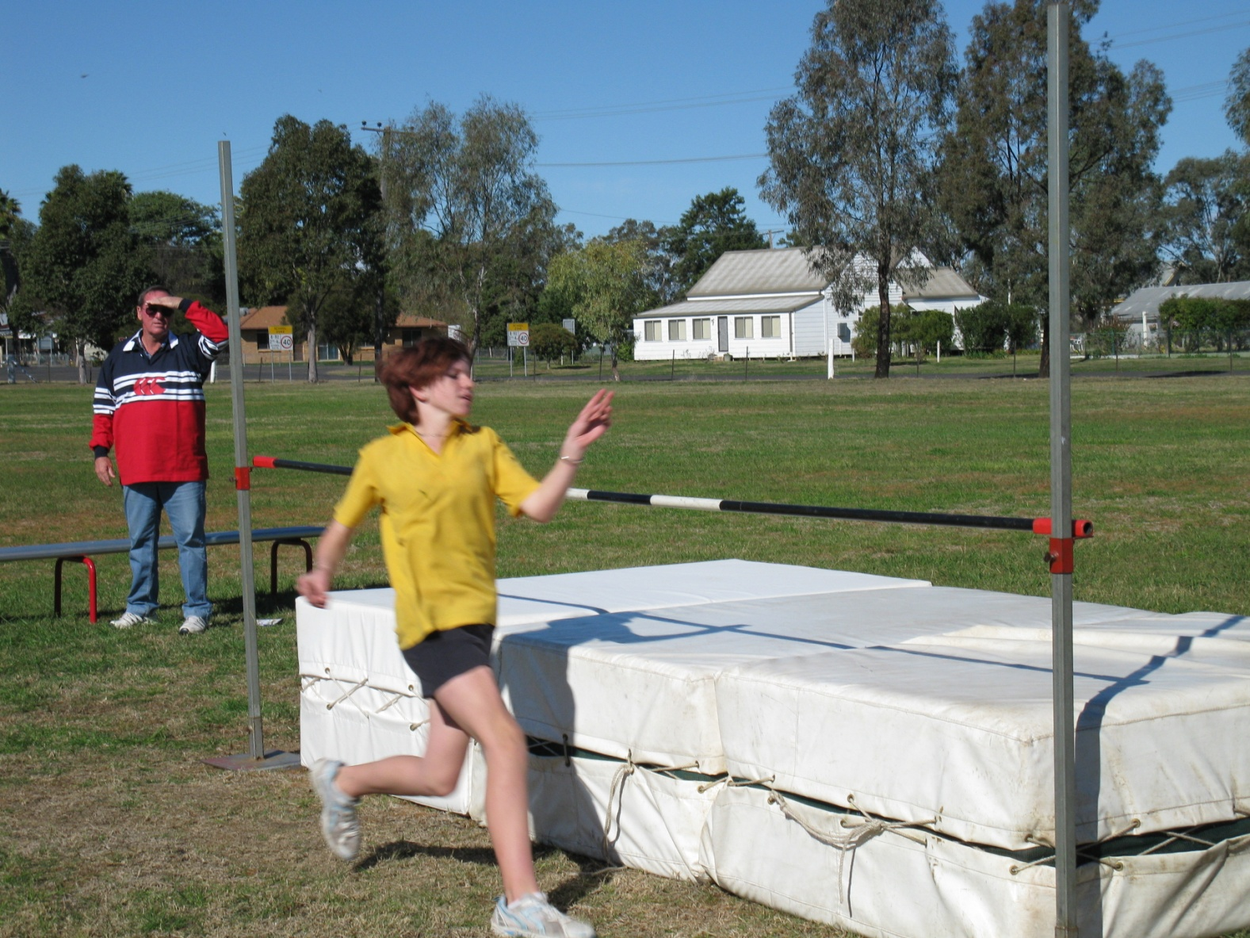

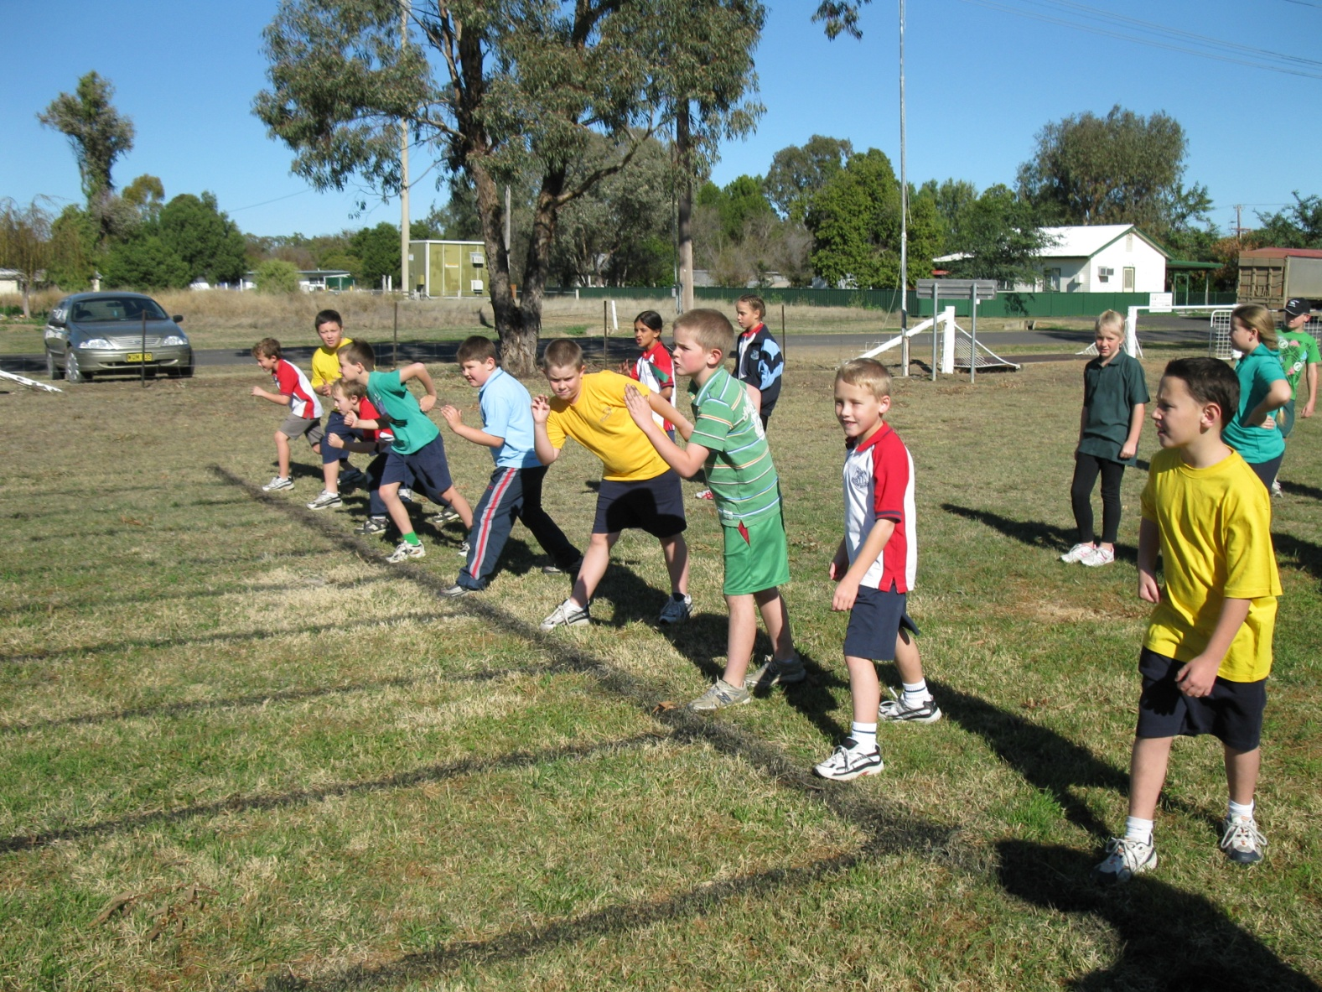

Community News

