Pallamallawa

Primary School
Ph: 67 549 209
Fax: 67 549 435

Newsletter
Wednesday,2nd September 2009

TOUCHFOOTBALL GALA DAY
Pally are hosting the Touchfootball Gala Day tomorrow, Thursday, 3rd September. Parents are welcome to come along and watch.
All students in 3-6 will be participating. They will need to wear their sports uniform. No football boots.
The first game will be at 10.30. The draw follows:
Field 1 Field 2
10.30 Rowena V Boomi Pally V Carinda
11.30 Pally V Rowena Carinda V Boomi
Lunch: 12.15
1.00 Rowena V Carinda Pally V Boomi
Games are twenty (20) minutes each way with five (5) minute half time.
The Pally P & C will be running a canteen. Steak sandwiches and sausage sandwiches will be for sale.
A big thank you to Kevin Rigby for training the students and assisting with the running of the Gala Day.
Students in K-2 will have a normal day at school. They will need to have a packed morning tea and lunch as usual.

School Photos Tuesday, 8th September
Reminder: Envelopes need to be returned to the office with exact amount in envelope.
All students need to be in full school uniform –
BLUE Shirt and blue shorts/skorts. Joggers or school shoes.
Order of photos: staff photo, whole school photo, class photos, individual photos, family photos, sport photos.
Jumpstart – 2009 Kinda Orientation/Transition to School Program
Jumpstart started last Wednesday. Our students all enjoyed the day.
Term 3 Dates: 9th 16th, 23rd September
Term 4 Dates: 21st, 28th October, 4th, 11th & 18th November.
Courtney and Ruby are busy creating an octopus.

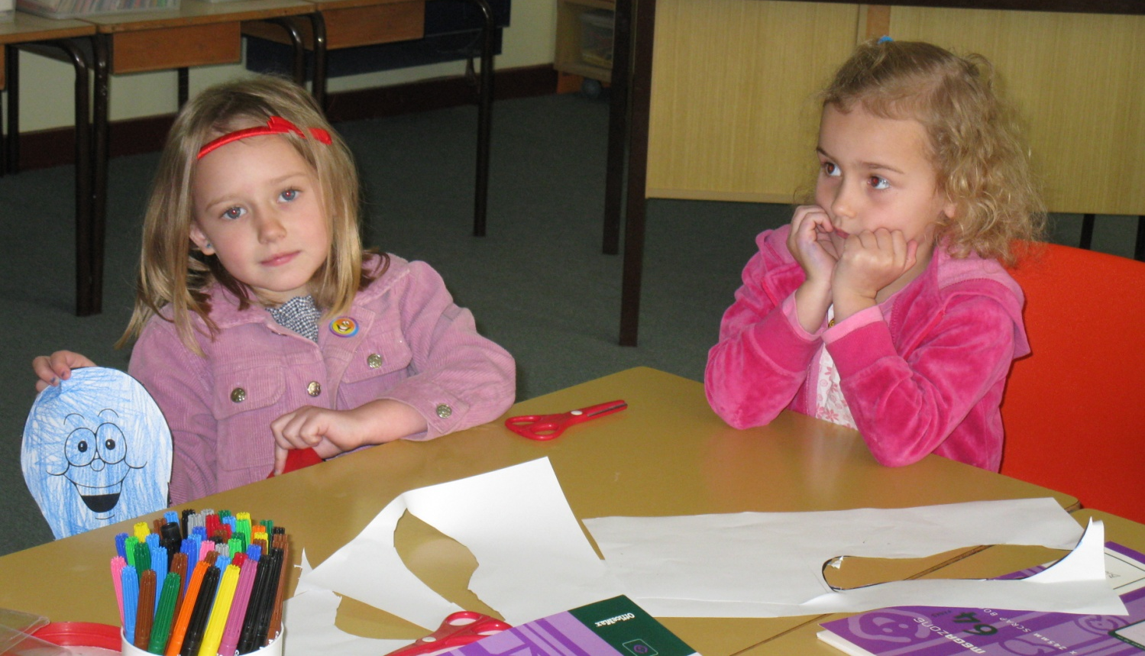

Sport

Change of Date Regional Athletic Carnival – Tuesday, 22nd September.

Joel Dell & Rhiannon Byers have been selected for the Regional Athletic Carnival in Tamworth.
Joel: 11 yrs 100m, 11 yrs Shot Put, 11yrs Discus, 11yrs Long Jump.
Rhiannon: Junior 200m, 10yrs 100m.

Dubbo Zoo Excursion

All permission and medical notes need to be returned.

Canteen News
Thank you to all our parents who assist with canteen. If you can assist with canteen please contact Lynette 67549490.
Canteen Roster
September Fri 4th John Quinnell
Mon 7th Lynette Taunton Fri 11th Melissa Goodworth
Mon 14th Kevin Rigby/Jodi Costello Fri 18th Rennae Hancock
Mon 21st Lynette Taunton Fri 25th Kathy Dwyer
Mon 28th Katreanna Byers October Fri 2nd NO CANTEEN

Calendar
Term 3

September
  - Thur 3rd PSSA Small Schools Touch Gala Day – Pally Hosting
  - Wed 9th Jumpstart Transition Program
  - Sat 12th 125years Pallamallawa School Celebration
  - Wed 16th Jumpstart Transition Program
  - Wed 23rd Jumpstart Transition Program
  - Thur 24th Public Speaking Competition
  - Wed 30th Excursion Dubbo Zoo

Celebrating 125 yrs of Public Education at Pallamallawa Public School.
Date: Saturday, 12th September
Welcoming Ceremony 11am

Past and present students, parents and staff and the community are invited to visit the school.
Come along, tour the school, catch up with old friends, enjoy lunch.
P & C are catering for lunch at a cost of $10 per person.

TO THE PARENTS OF PALLY STUDENTS REQUEST FROM THE P & C

The P & C will be catering for the 125 years celebration. They need parents to assist with salads, slices and cakes. For more information contact the office at School.

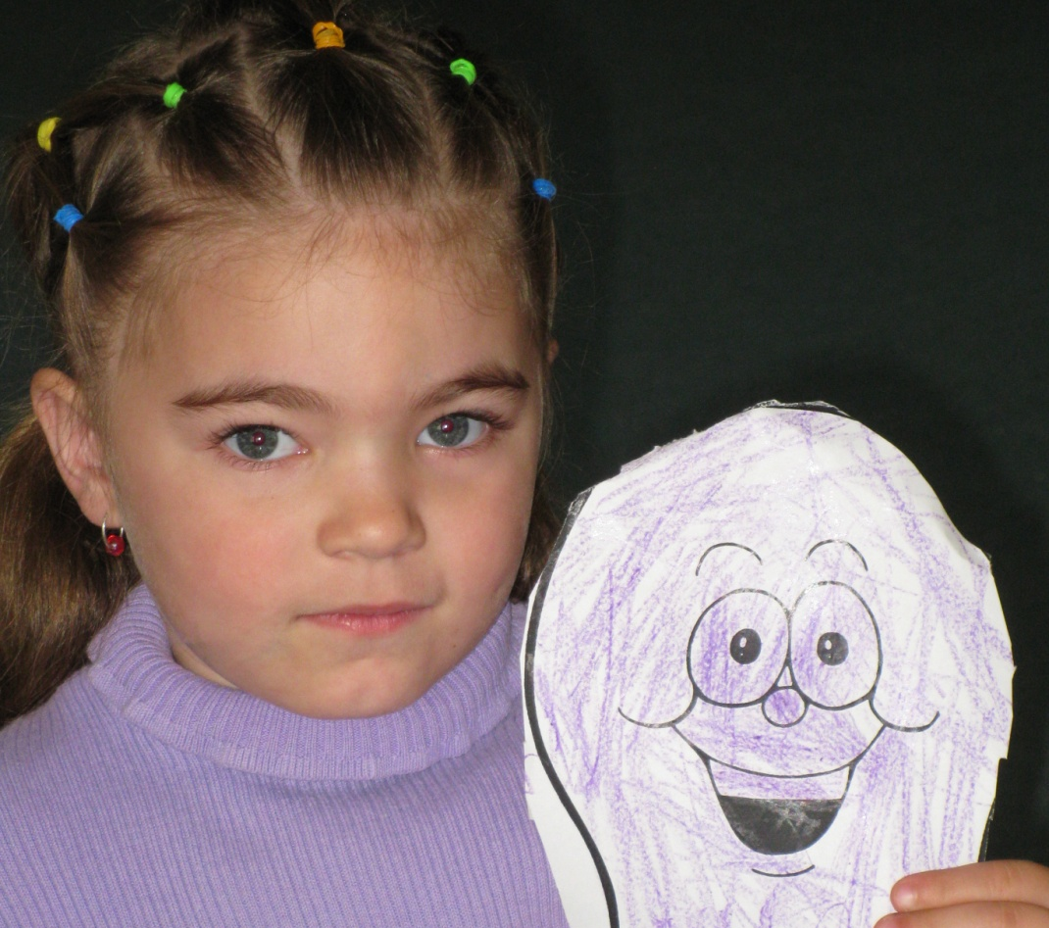

Jumpstart students with their octopus.
