# pallAMALLAWA logo SML Pallamallawa

# Primary School

Ph: 67 549 209

Fax: 67 549 435

#### **Newsletter - Thursday, 25th March 2010**

**P & C AGM**

**(TONIGHT)**

**Thursday, 25th March**

**7.30pm**

Friday 19.3.10 Awards

K-2: Madalyn Crouch, Garry Goodworth-Bell

3-6: Harry Whibley, Mathew McNamara

**Harmony Day**

Last Monday we celebrated Harmony Day. Thank you Lynette Taunton for organising the sausage sizzle.

**3,4,5,6 - Excursion to Canberra**

Reminder that the non refundable deposit of $50 is **due by the end of the term.**

**Congratulations Rhiannon**

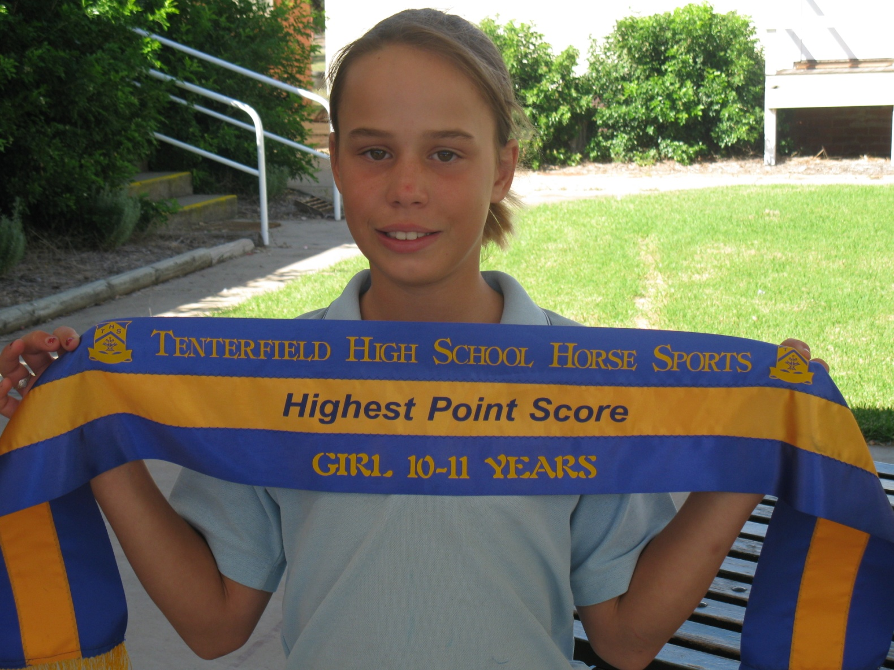

**Last week Rhiannon competed at the Tenterfield High School Horse Sports. She won the Highest Point Score in her age group. Well Done**

**Sport News**

Cross Country training has commenced. Wednesday and Friday are training days. All students need to wear joggers for this activity.

**ASSEMBLY**

**Thursday 1st April 2.30pm**

**Canteen News**

**Looking for suggestions to add to our canteen menu - contact Lynette.**

**Thank you to all our parents who came forward to help with the roster.**

**Roster for Term 1**

Fri 26th Jill Walker

Mon 29th Kathy Crouch

**Uniforms**

Shirts, skorts, shorts have arrived. Size 16 shirts on back order.

**Polar Fleece jumpers have just arrived. Price Child $25 Adults $28**

New Prices – School Shirt $16; Sport Shirt $17

**Calendar**

**Term 1**

March

* + **Thur 25th P & C AGM – 7.30pm**
  + **Tue 30th School Council Meeting - 2pm**
  + **Wed 31st Mrs Rush & Mrs Schwartz – Reading to Learn Professional Dev.**

#### **April**

* + **Thur 1st Assembly 2.30pm**
  + **Thur 1st Last Day Term 1**

**Term 2**

April

* + **Sun 18th / Mon 19th Small School Conference – Inverell**
  + **Tue 20th Students First Day Term 2**
  + **Sun 25th ANZAC Day**
  + **Mon 26th Public Holiday – ANZAC Day**

May

* + **Wed 5th Power Down Challenge Day**
  + **Tue 11th NAPLAN Year 3 & 5 Writing**
  + **Wed 12th NAPLAN Year 3 & 5 Reading**
  + **Thur 13th NAPLAN Year 3 & 5 Numeracy**
  + **Fri 14th Inland Mission Visiting**
  + **Wed 19th / Thur 20th Vibe Alive – Moree**

**COMMUNITY NEWS**

**C:\Program Files\Microsoft Office\Media\CntCD1\ClipArt2\j0230167.wmf**

**MOREE JUNIOR CRICKET**

**Saturday 27th March is Grand final Day**

**Divisions 1 & 2 will commence at 8.30am.**

**Divisions 3 & 4 will commence at 10.00am**

**All games should be finished by 12 midday. We will then have our trophy presentations.**

**There will be a sausage sizzle and drink for all registered players.**

**Ann Maree Cubis & Debbie Holland**

**C:\Program Files\Microsoft Office\Media\CntCD1\ClipArt4\j0250165.wmf**

**MOREE HOCKEY ASSOCIATION**

**Moree Hockey Association will be holding a sign on day at Ron Harborne Oval this**

**Saturday 27 March between 11:00 am and 12:00 noon**

**If you have any enquiries please contact Libby Smith on 67 546 120**