# pallAMALLAWA logo SML Pallamallawa

# Primary School

Ph: 67 549 209

Fax: 67 549 435

#### **Newsletter - Thursday, 1st April 2010**

**Assembly Awards**

**Principal Awards**: Garry Goodworth-Bell, Gavin Hancock

**K-2 Awards**: Timmy Moore, Ruby Tighe, Cassidy Hobday, Hyrum Van Kralingen

**3-6 Awards**: Rhiannon Byers, Wade Newcombe, Jordon Brazel

Special Awards: Lauren Morton, Tameka Reynolds, James Whibley, Bradman Walker, Mathew McNamara, Gavin Hancock, Hyrum Van Kralingen, James Walker, Ben Whibley, Zack Crouch

**Attendance Awards**: Ella Babington, Ben Whibley, Harry Whibley, James Whibley.

**School Council Meeting Tuesday 30th March**

The School Council held its first meeting for the term on Tuesday.

President: Lynette Taunton

Secretary: Jill Walker

Chairman: Mrs Faye Sullivan

The School Council will next meet in Term 2 on Tuesday, 18th May at 2pm.

The School Council is an opportunity for parents to have discussion about what is happening at the School. The parent representatives can put forward discussion on behalf of the school community or items will be discussed when put in writing. Parents are invited to attend the meetings as observers.

**Expression of Interest CPR Training / Emergency Care**

The School will be conducting Staff Training in **CPR** and **Emergency Care** on **Saturday, 1st May at 9am**. The community is invited to participate at a cost of **$25 for each course**. Please contact the office if you interested in participating. Payment for each course to be paid before the day.

**School Resumes Tuesday, 20th April.**

**Canteen News**

The P & C discussed the Healthy kids Program & Crunch & Sip

It was decided to trial a fresh fruit on Friday. Free for all children. Each family is being asked to supply fruit for one Friday twice a year. A roster will be sent home next term with fruit suggestions. Fruit can be sent in for the Canteen helper to cut up and distribute. This will be served at lunch time.

**Canteen Roster**

Term 2

Apr Fri 23rd Lynette

**School Canteen – Uniforms**

Lynette will be available for parents to purchase uniforms when we return Tuesday, 20th April at 9am.

**Calendar**

**Term 2**

April

* + **Sun 18th / Mon 19th Small School Conference – Inverell**
  + **Tue 20th Students First Day Term 2**
  + **Sun 25th ANZAC Day**
  + **Mon 26th Public Holiday – ANZAC Day**

May

* + **Wed 5th Power Down Challenge Day**
  + **Tue 11th NAPLAN Year 3 & 5 Writing**
  + **Wed 12th NAPLAN Year 3 & 5 Reading**
  + **Thur 13th NAPLAN Year 3 & 5 Numeracy**
  + **Fri 14th Inland Mission Visiting**
  + **Tue 18th School Council Meeting 2pm**
  + **Wed 19th / Thur 20th Vibe Alive – Moree**

**The Staff wish everyone an enjoyable Easter Break.**

**Year 3 – 6 Experimenting with Mystery Powders**

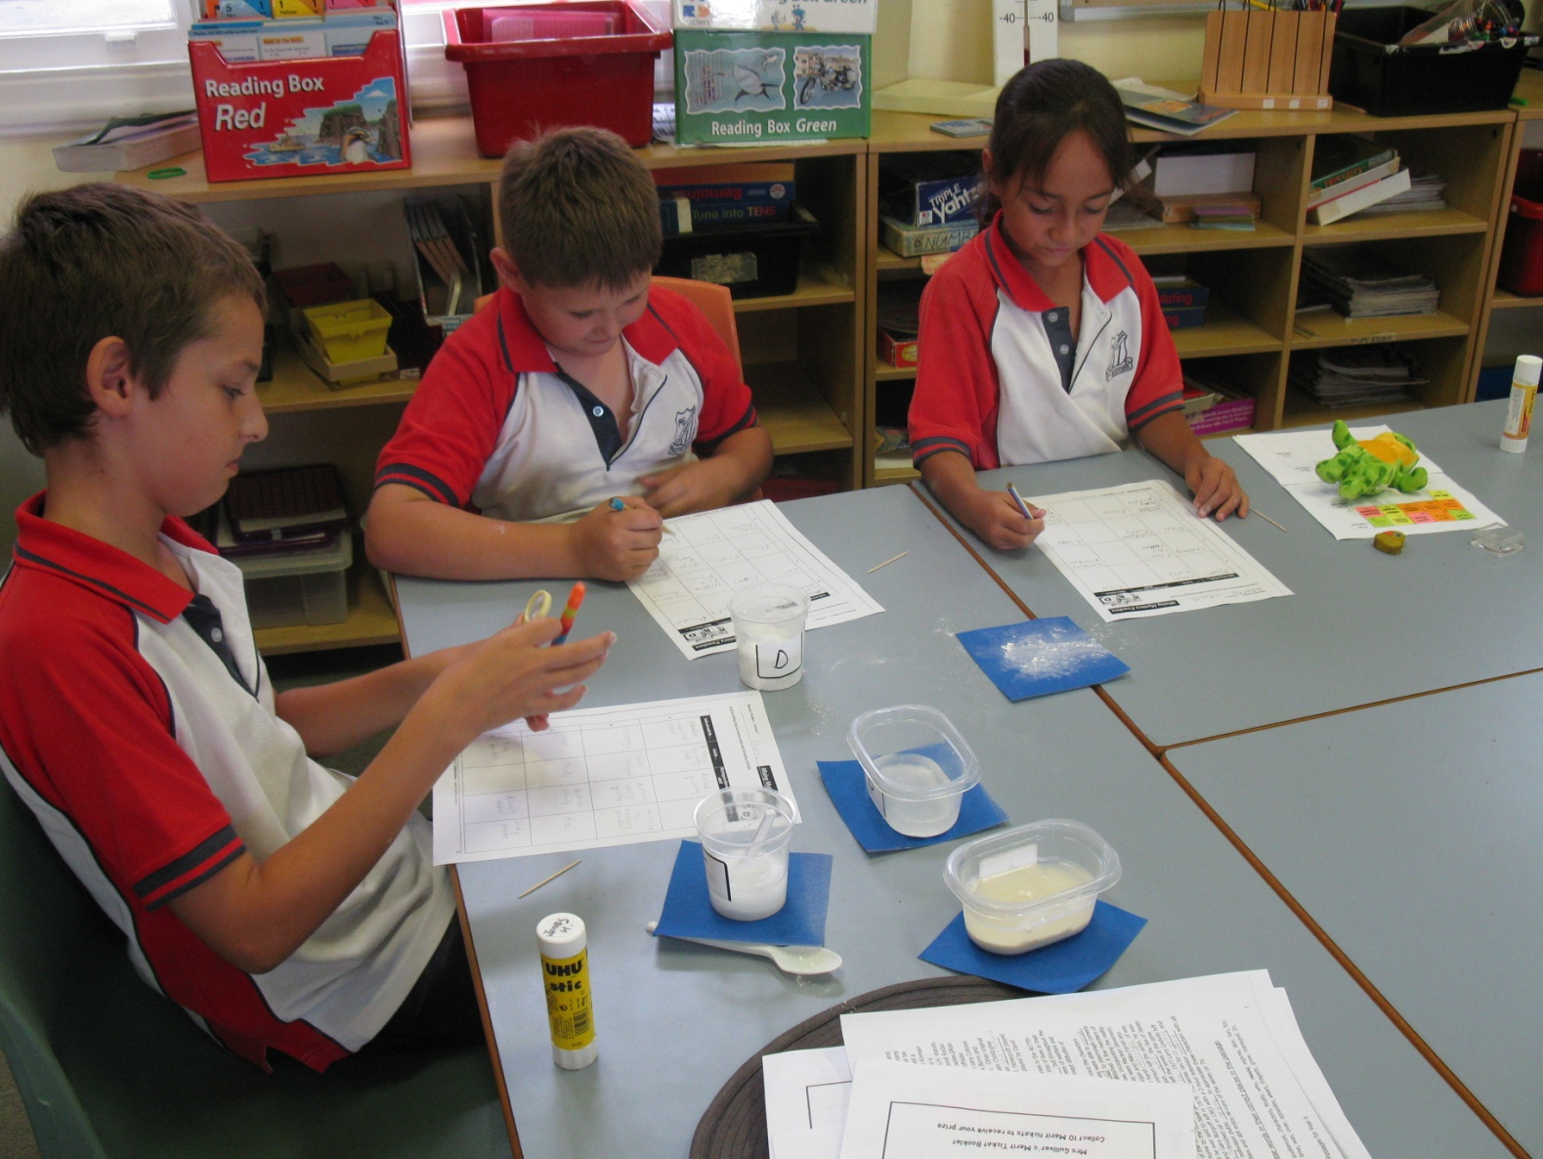

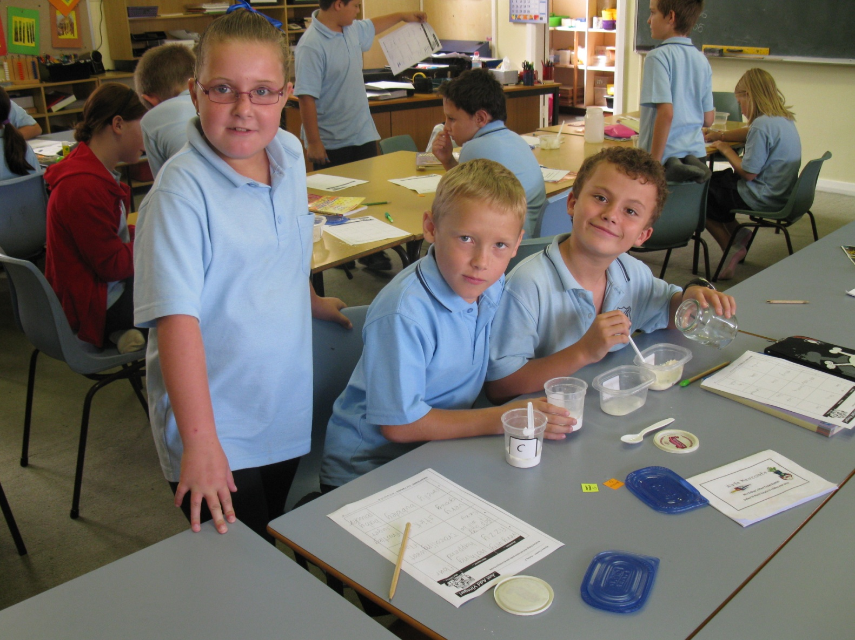

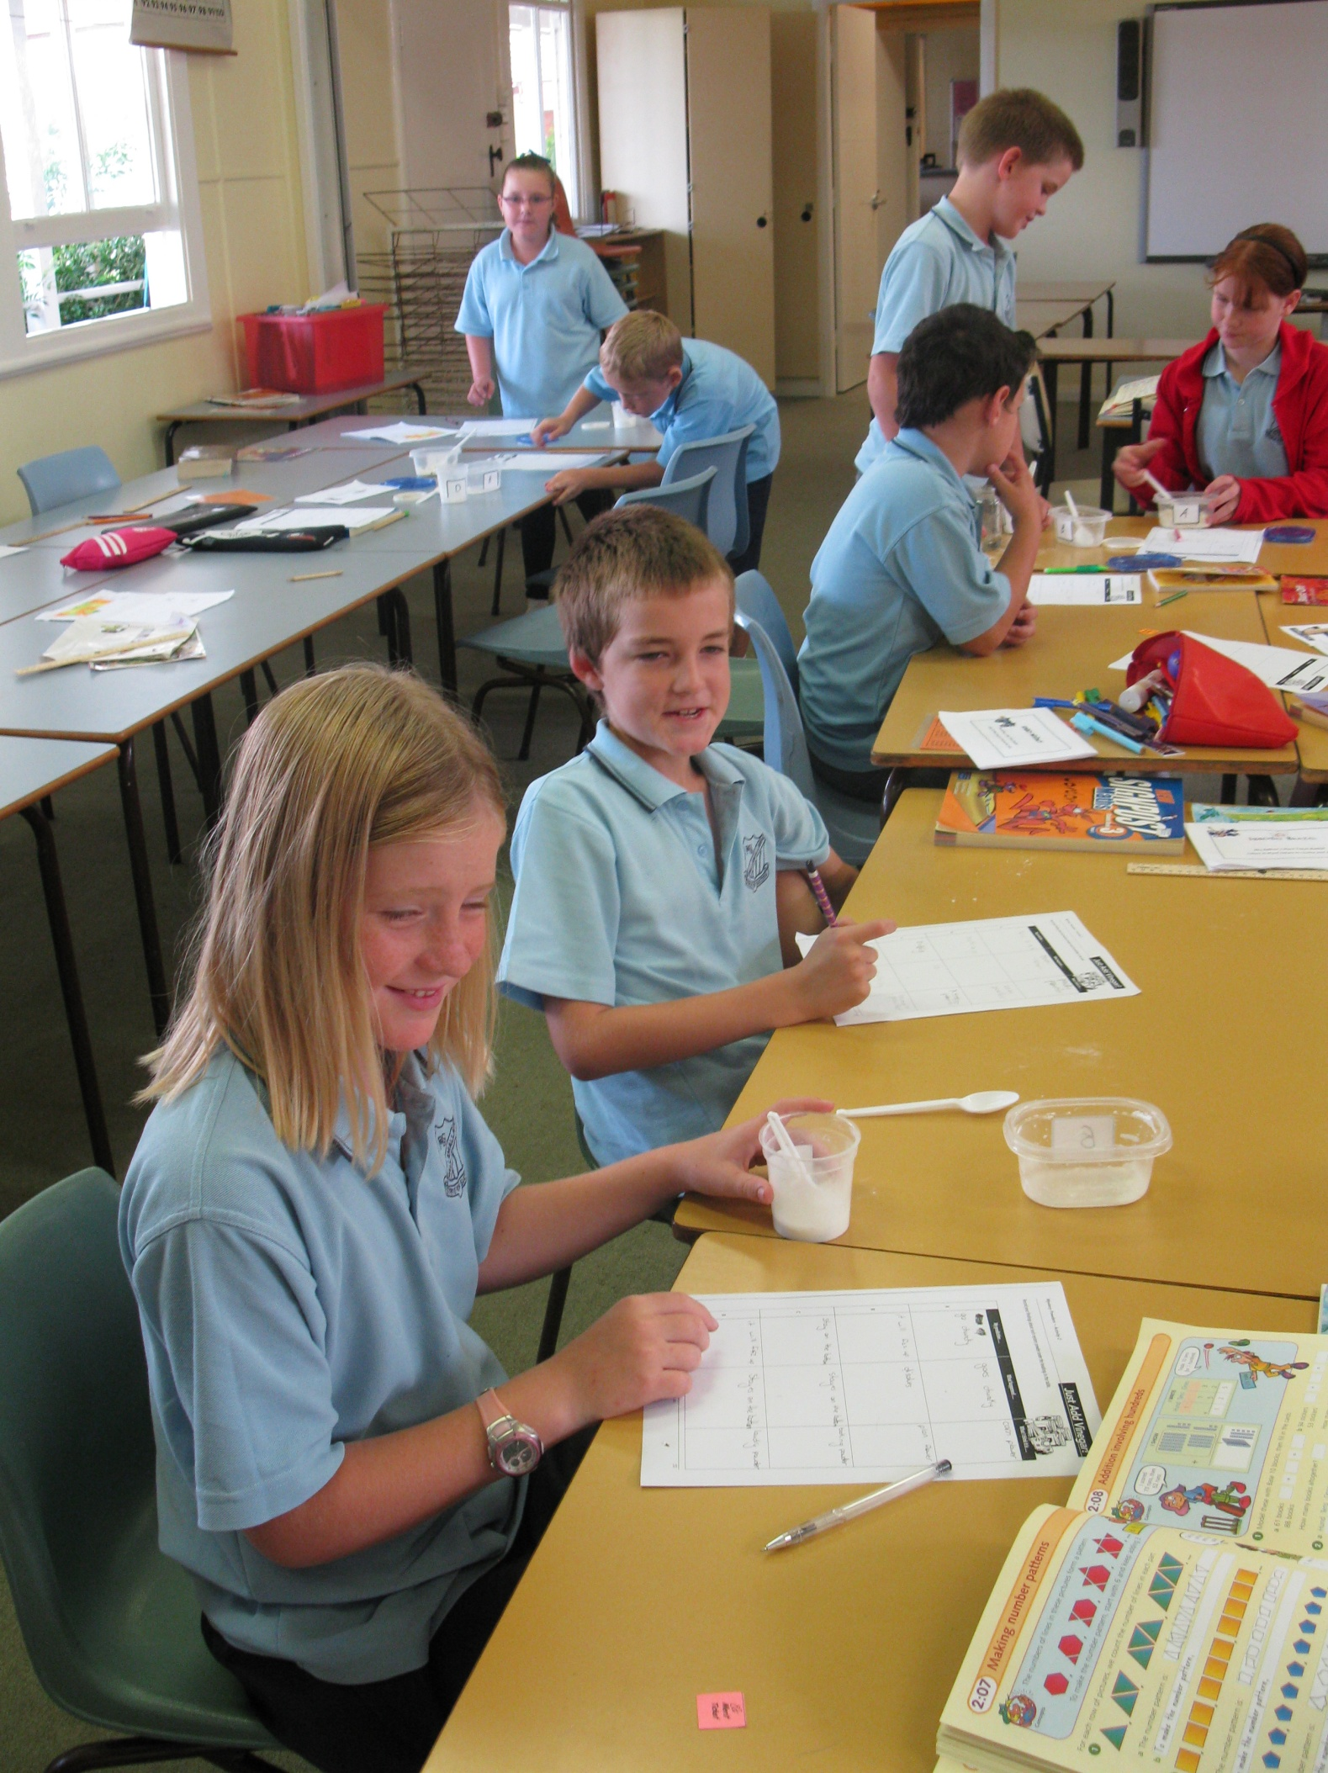

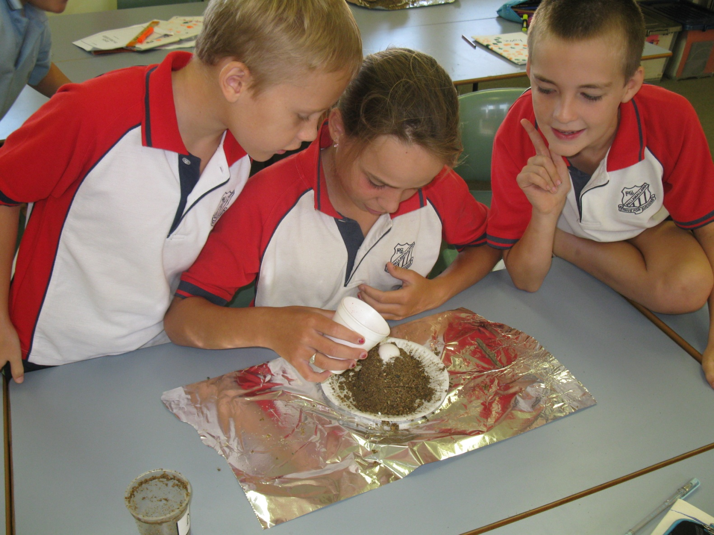

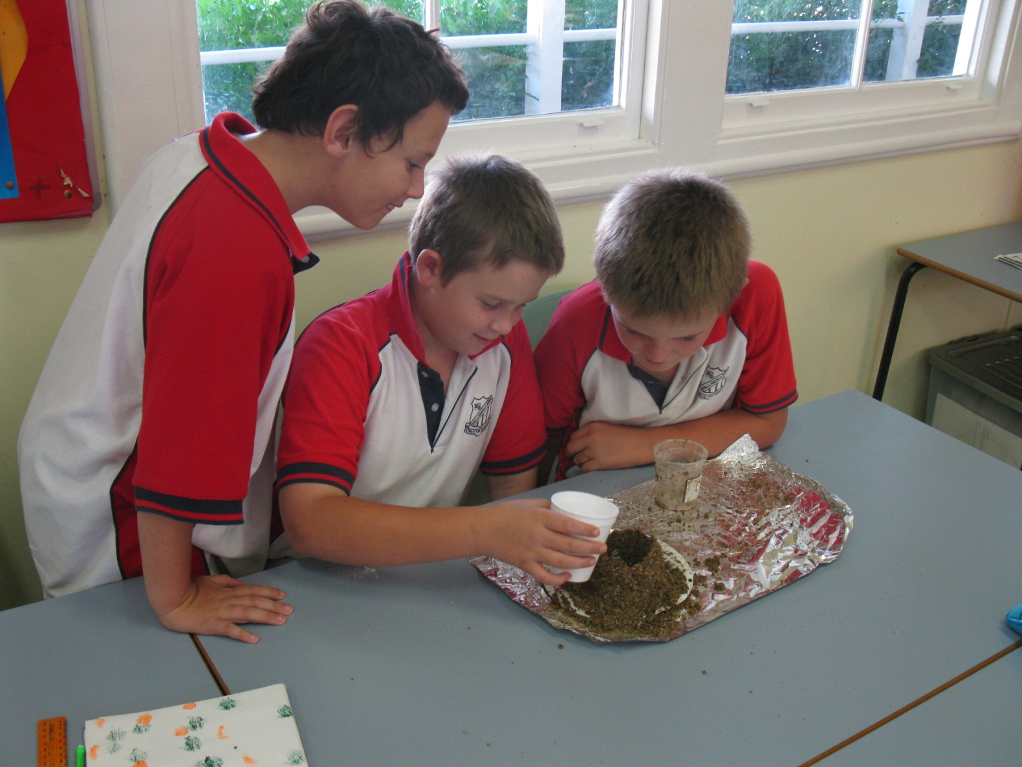

**K-2 Artwork**

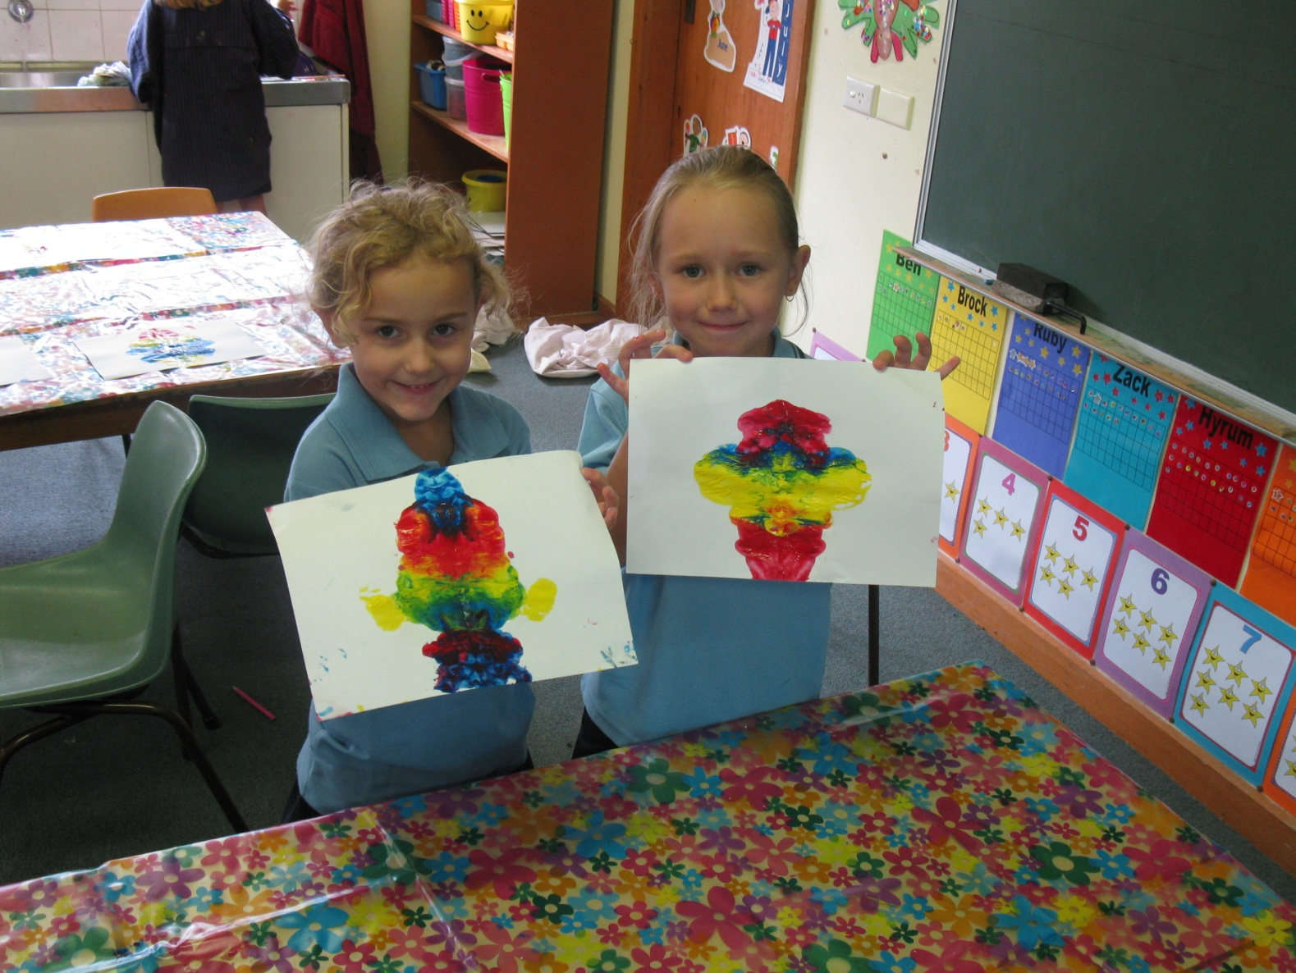

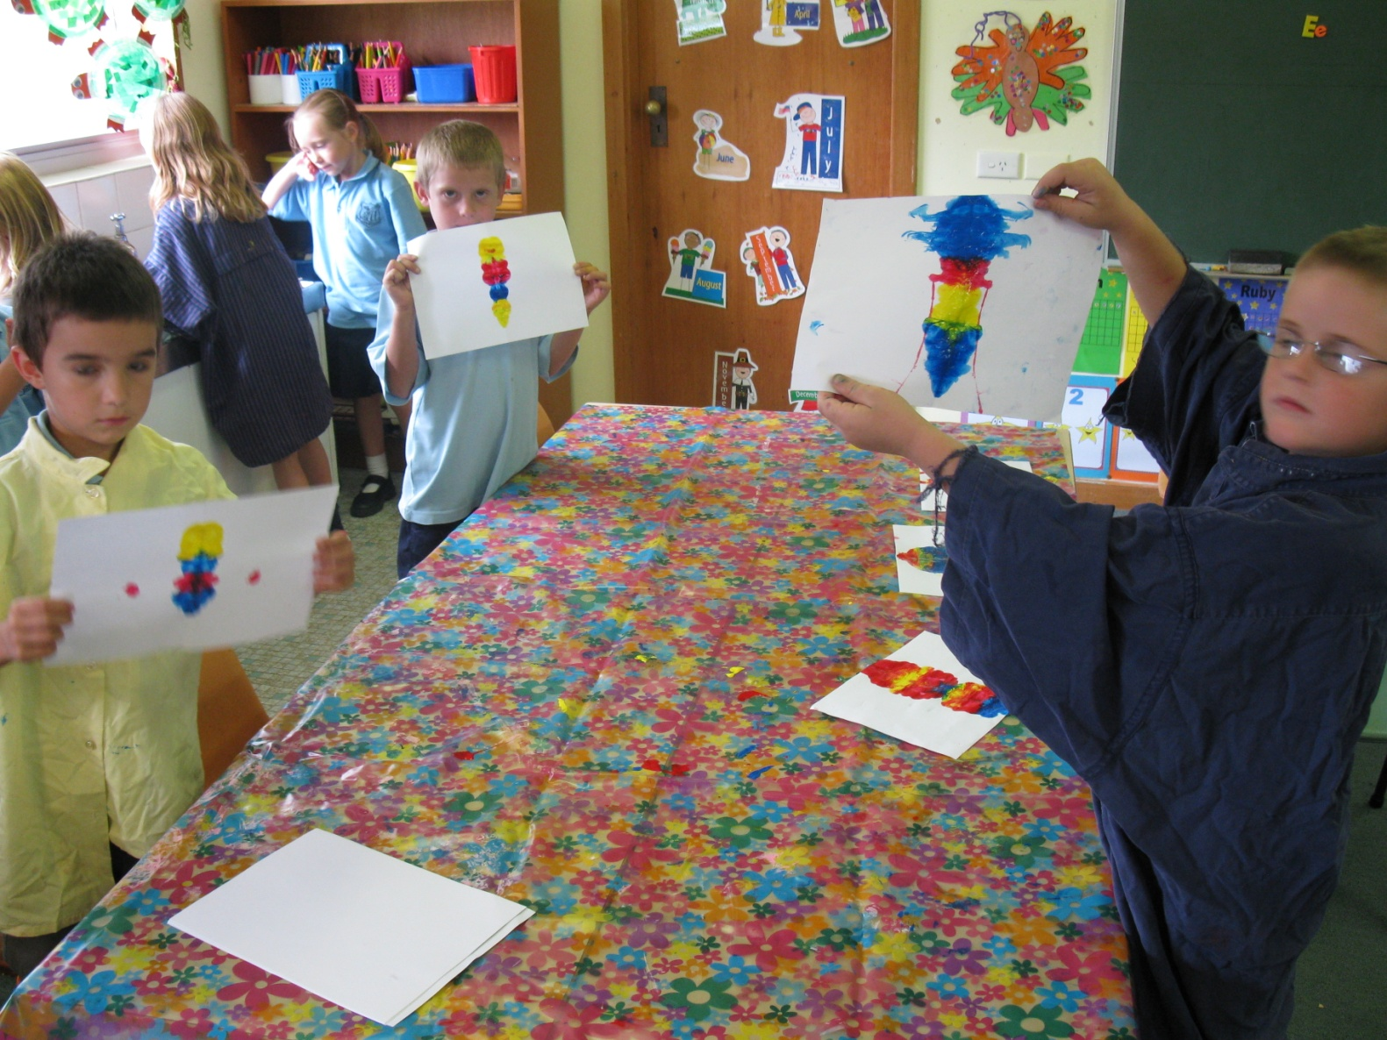

**Harmony Day Dance**

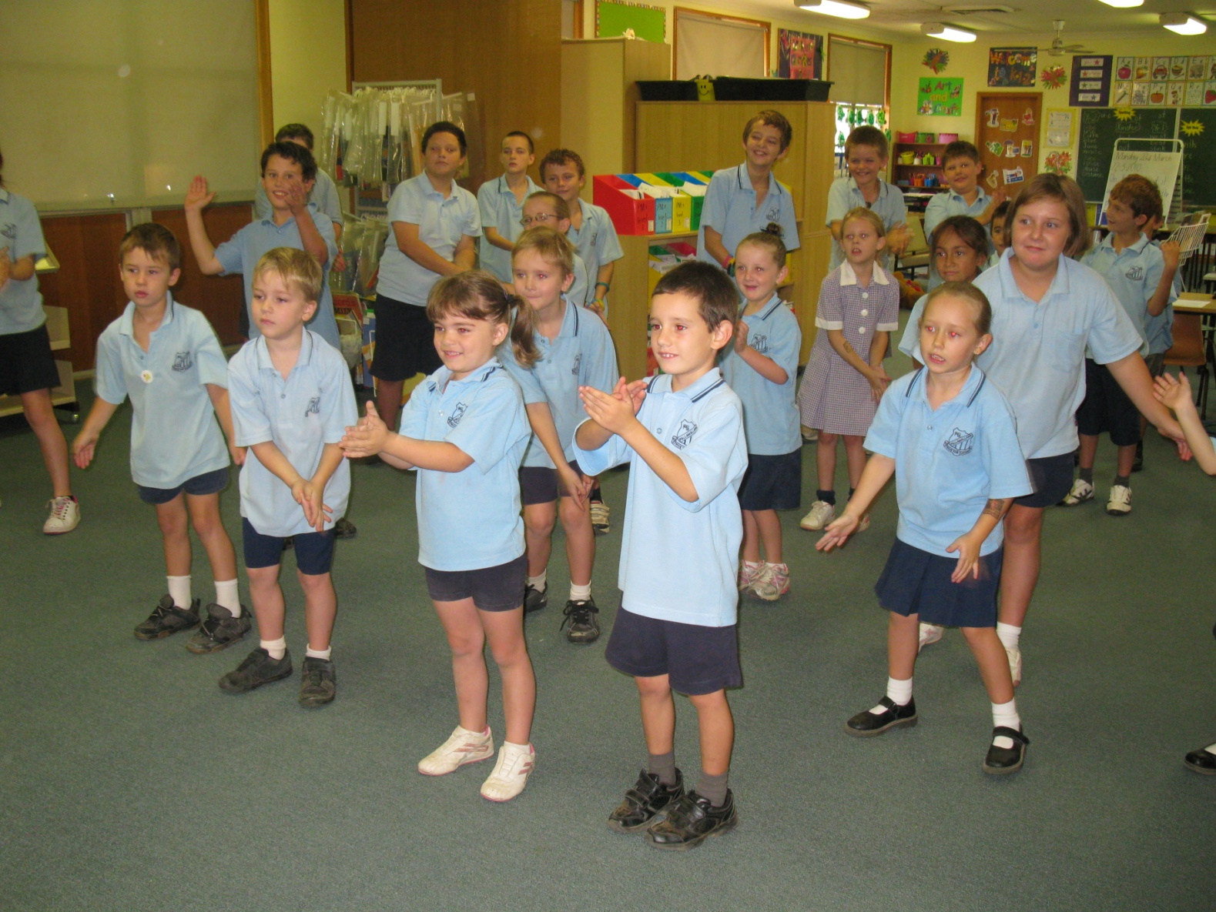

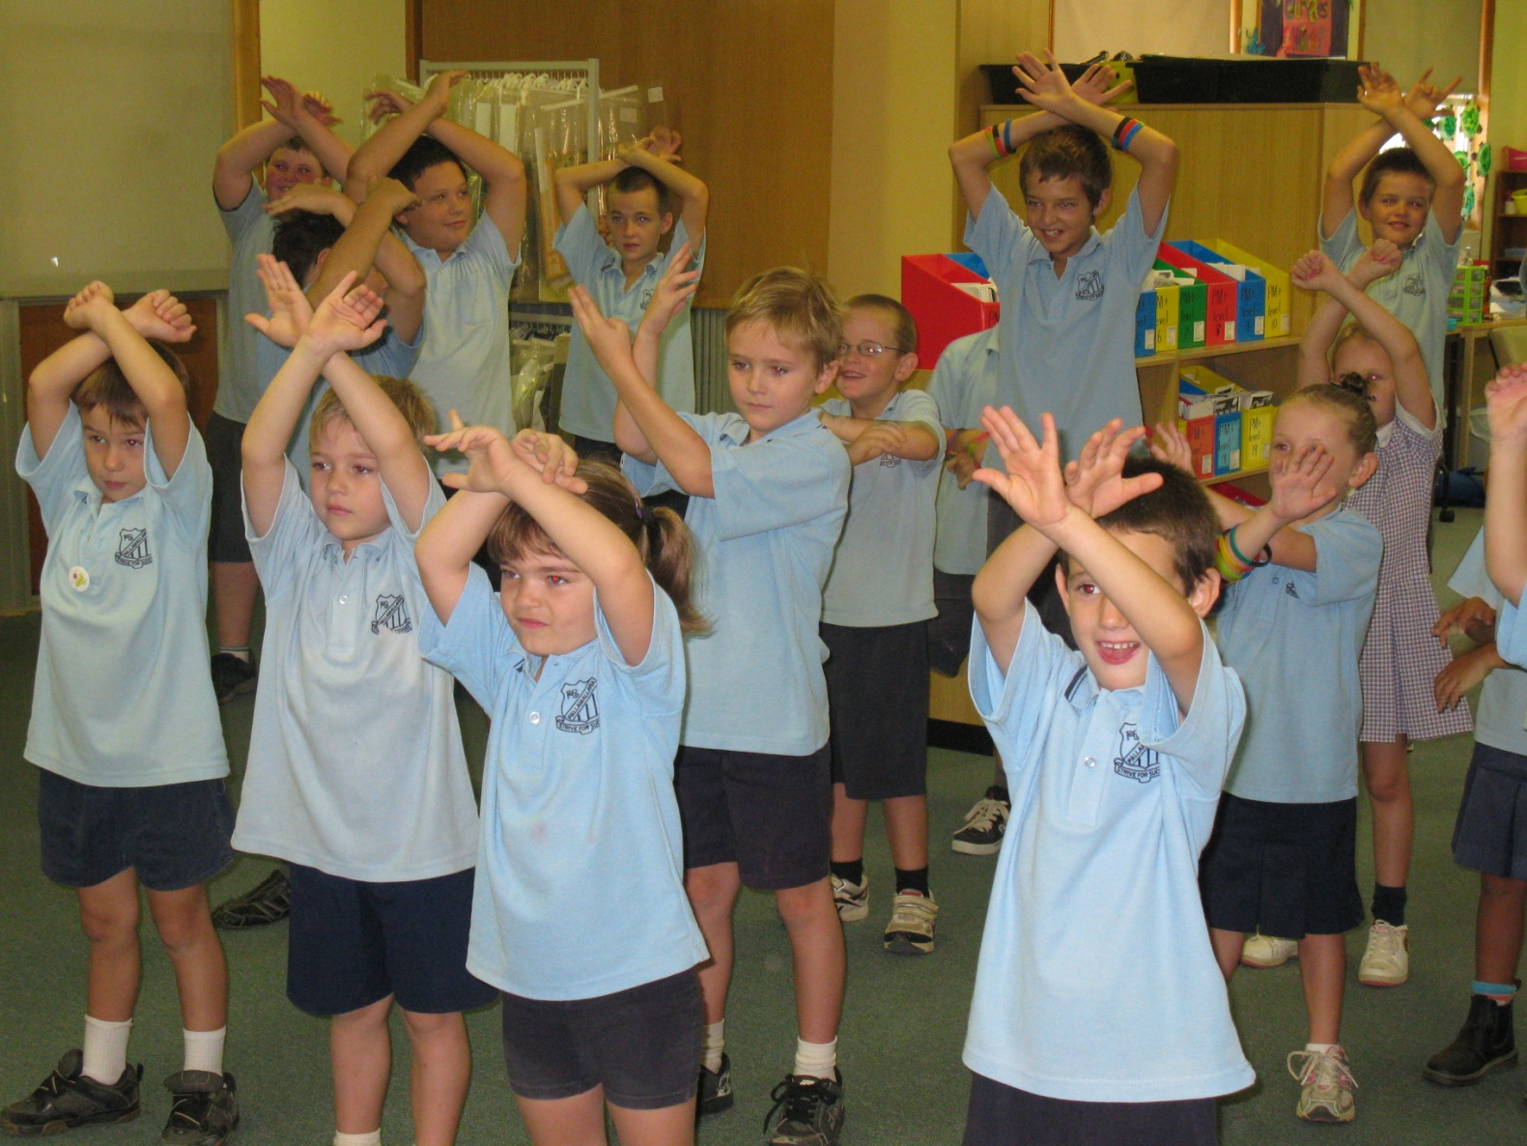

**COMMUNITY NEWS**

**C:\Program Files\Microsoft Office\Media\CntCD1\ClipArt4\j0250165.wmf**

**Junior Hockey Registration**

Another registration day will be held for Junior Hockey on Wednesday, 31st March from 4.00-5.30pm at Ron Harbourne Oval. Cost: 9yrs & under = $45; over 9yrs = $65. The season will begin after the holidays on Saturday, May 1st. If there are any questions, please call Libby Smith on 67546120 or Helen on 67522827.

**MOREE SHOW**

The countdown is on for this year's Moree Show! The 2010 show will be held on April 16, 17 and 18 and will feature lots of cool rides and attractions. Why not get busy over Easter creating your own Scarecrow for the inaugural Moree Show Scarecrow competition? Or brush up on your cooking, art, scrapbooking or photography skills for the pavilion competitions? For all you little cowboys and cowgirls, there will be a Friday Night Rodeo on April 16 as well as a Whip-cracking competition at the show. And the Toyota Hilux Heros will be back in force, as will the Lawnmower Races. There's something for everyone at The Moree Show! See [www.moreeshow.com.au](https://webmail.det.nsw.edu.au/owa/redir.aspx?C=53cea336aaec41089bccb8512c88936f&URL=http%3a%2f%2fwww.moreeshow.com.au%2f) for further details.

**Happy Easter Everyone**

**C:\Program Files\Microsoft Office\MEDIA\CAGCAT10\j0304933.wmf**

**C:\Program Files\Microsoft Office\Media\CntCD1\ClipArt5\j0280335.wmf**

**C:\Program Files\Microsoft Office\Media\CntCD1\ClipArt5\j0286841.wmf**



**HAVE A RESTFUL AND ENJOYABLE**

**EASTER**